Project Design Phase-II
Data Flow Diagram & User Stories

Date | 3 February 2026
Team ID | LTVIP2026TMIDS57703
Project Name | Civil Engineering Insight Studio
Maximum Marks | 4 Marks

Data Flow Diagrams:
A Data Flow Diagram (DFD) visually represents how data moves through the Civil Engineering Insight Studio system. It shows how user input (text + image) is processed by the AI model and how structured engineering insights are generated and displayed.
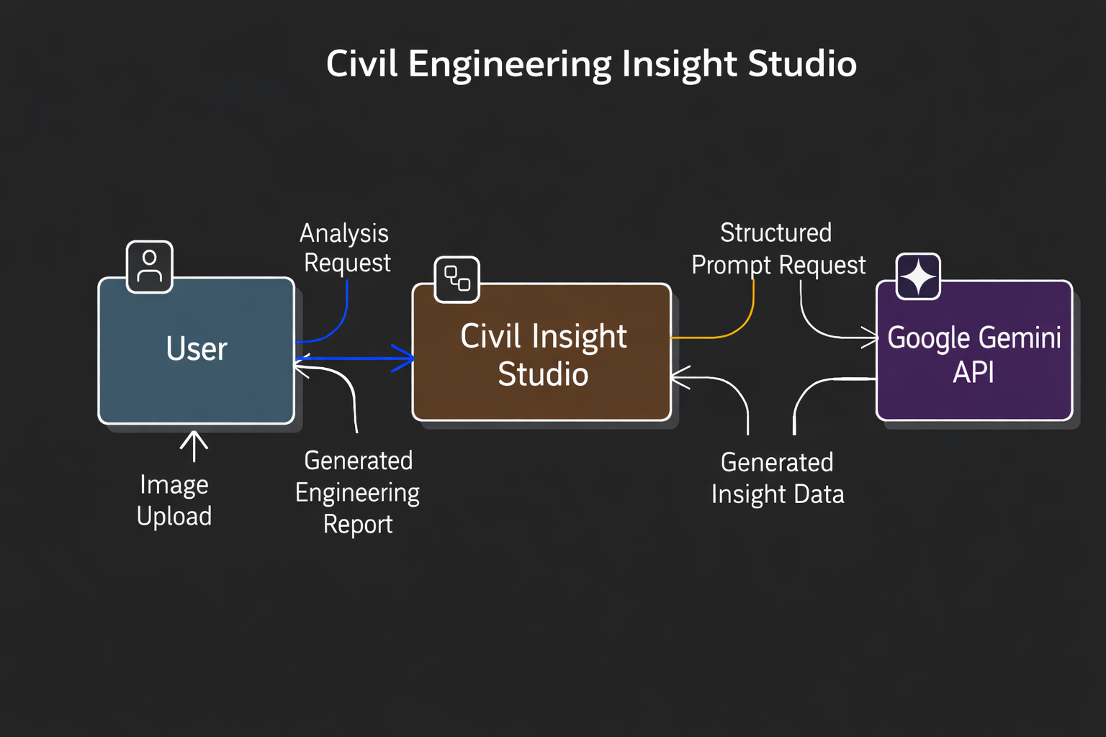
DFD Level 0 (Industry Standard)
DFD Level 1 (Industry Standard)
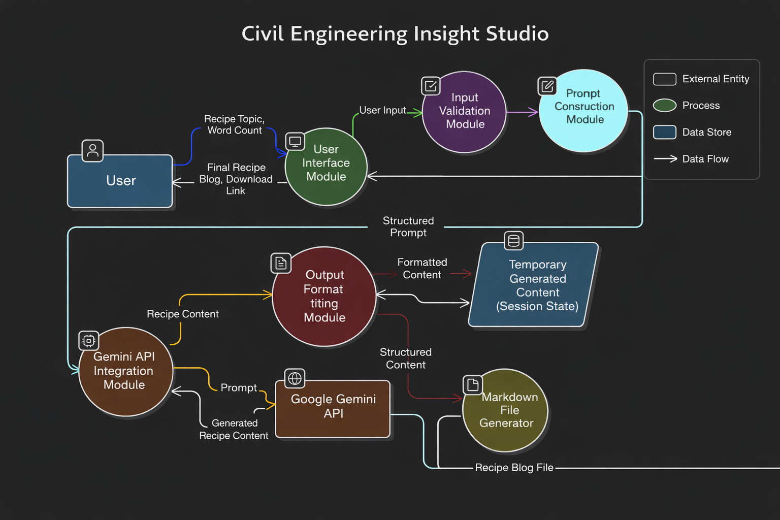
Example: 
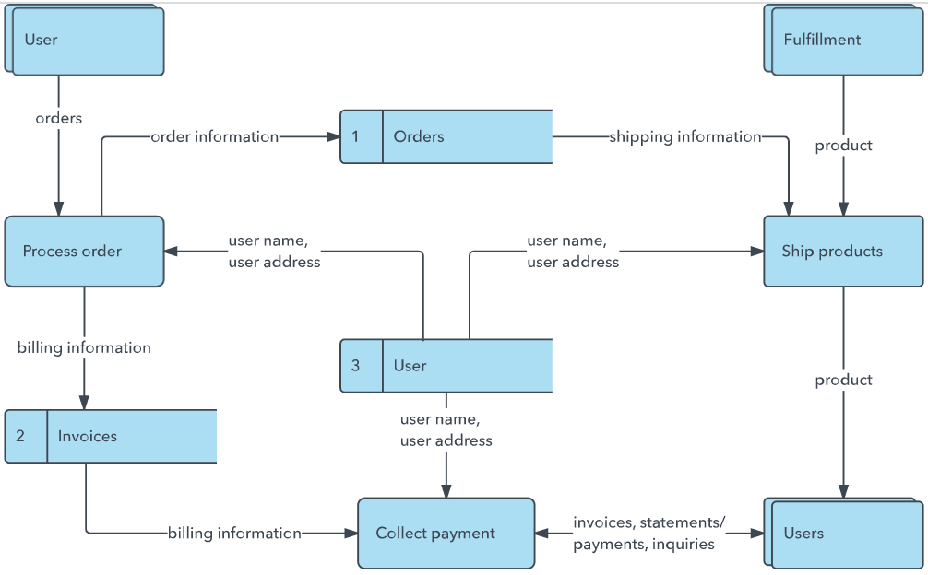

User Stories
Use the below template to list all the user stories for the product.
User Type | Functional Requirement (Epic) | User Story Number | User Story / Task | Acceptance Criteria | Priority | Release
Civil Engineer (Web User) | Upload Construction Image | USN-1 | As a user, I can upload a construction site image so that the system can analyze the structure. | System accepts JPG/PNG images and displays preview before analysis. | High | Sprint-1
Civil Engineer (Web User) | Enter Analysis Request | USN-2 | As a user, I can enter a structural analysis request. | System accepts text input and includes it in the AI prompt. | High | Sprint-1
Civil Engineer (Web User) | AI Structural Analysis | USN-3 | As a user, I can generate a detailed structural report using AI. | System identifies materials, structural components, and construction stage. | High | Sprint-1
Civil Engineer (Web User) | Display Generated Report | USN-4 | As a user, I can view the generated structural analysis directly on the screen. | Generated report appears clearly formatted in the UI. | High | Sprint-1
Civil Engineer (Web User) | Download Report | USN-5 | As a user, I can download the generated structural report. | Clicking download provides a valid report file containing generated content. | High | Sprint-1
Civil Engineer (Web User) | Input Validation | USN-6 | As a user, I am prevented from generating analysis without uploading an image. | System shows validation message and blocks analysis. | High | Sprint-1
Civil Engineer (Web User) | Regenerate Analysis | USN-7 | As a user, I can regenerate analysis by modifying the prompt or uploading a new image. | New output replaces previous result without system error. | Medium | Sprint-2
System | Gemini API Integration | USN-8 | As the system, I must send image + structured prompt to Google Gemini API and receive a response. | API request succeeds and returns structured engineering insights. | High | Sprint-1
System | Error Handling | USN-9 | As a user, I receive an error message if AI analysis fails. | System displays clear error message without crashing. | Medium | Sprint-2

